By: Marcus Brooks

May need to be opened in Microsoft word to be viewed properly

CMSC 204

Huffman Lab

1. Create a Huffman Tree and generate the codes for each character of the following input:

create a huffman tree

For consistency:

1. If same frequency – put in priority queue alphabetically; put space before other characters of the same frequency
2. Add subtrees to end of group with same priority
3. Lower number has higher priority (goes to front)

21

13

7

3

8

6

4

4

E | 4

2

2

A| 3

Space| 3

T| 2

R | 2

C | 1

N | 1

M | 1

H | 1

F | 2

U | 1

This Huffman Tree was created assuming that Space was meant to be enqueued before characters of the same frequency

Now encode “create a huffman tree”

0100000111101001111100101010111001101110101101010111100001000111111

1. Based on the following Huffman tree and binary sequence, what is the text

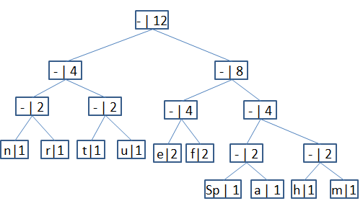

1110011101101111111010001100010001100100

Huffman tree